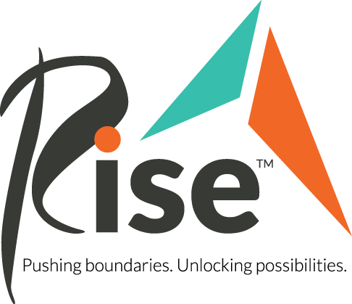
Item Donation Wish List
Thank you for your interest in supporting Rise with in-kind and product donations. Please review our list of needs below.
Once you know what you would like to donate, please reach out to tbrinker@rise.org to coordinate approval and drop-off at a Rise location.
Amazon Wish List: https://www.amazon.com/hz/wishlist/ls/2ULCC5WPZ0X4V?ref_=wl_share
Art Speaks supplies (new preferred):
- Crayola Washable Markers
- Crayola Crayons
- Crayola Colored Pencils
- Sharpie Markers, various colors
- Acrylic paint tubes
- Craft Paint
- Paint brushes, preferred large, round, long-handle brushes
- Canvas
- XL Mixed Media Paper Book
- XL Watercolor Paper Book
- Cardstock (letter-sized), various colors
- Painter’s Tape, preferred brands: Scotch Blue, Duck

Program Snacks (new, unopened only):
- Snack Packs
- Bulk snack boxes

Personal Care Products (new only)
- Disposable Adult Briefs – various sizes
- Deodorant, shampoo, conditioners, laundry detergent

Ideas?
- For clothing drives and other in-kind donations, including ideas you may have, please reach out! Besides the Amazon Wish List, coordinate with us before collecting or delivering donations. Our storage space is limited so we can’t accept unsolicited or unapproved donations.

