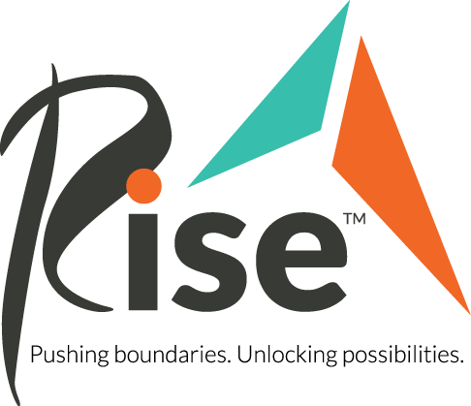
Item Donation Wish List
Thank you for your interest in supporting Rise with in-kind and product donations. Please review our list of needs below.
Once you know what you would like to donate, please reach out to tbrinker@rise.org to coordinate approval and drop-off at a Rise location.
Art Speaks supplies (new preferred):
- Crayola Washable Markers
- Crayola Crayons
- Crayola Colored Pencils
- Sharpie Markers, various colors
- Acrylic paint tubes
- Craft Paint
- Paint brushes, preferred large, round, long-handle brushes
- Canvas
- XL Mixed Media Paper Book
- XL Watercolor Paper Book
- Cardstock (letter-sized), various colors
- Painter’s Tape, preferred brands: Scotch Blue, Duck

Program Snacks (new, unopened only):
- Snack Packs
- Bulk snack boxes

Michael’s Closet (new or gently used & washed only):
- Black Pants (women’s, men’s, various sizes)
- Khaki Pants (women’s, men’s, various sizes)
- Polo Shirts – neutral colors and red (women’s, men’s, various sizes)
- Non-Slip work shoes (women’s, men’s, various sizes)
- Steel-Toe work boots (women’s, men’s, various sizes)

Personal Care Products (new only)
- Disposable Adult Briefs – various sizes
- Deodorant, shampoo, conditioners, laundry detergent

Amazon Wish List: https://www.amazon.com/hz/wishlist/ls/2ULCC5WPZ0X4V?ref_=wl_share

