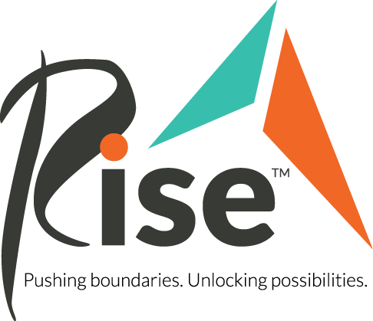
What changes were made because of the 2020 Legislative Session?
After a drastic turnaround due to the upset of the COVID-19 Pandemic, the 2020 legislative session focused on maintaining stable funding and receiving emergency relief for people with disabilities. Near the end of the legislative session, the Disability Service Retention and Public Health Grants Bill was passed, which was crucial to helping people with disabilities thrive and be successful during the ongoing pandemic.
What is the Disability Service Retention and Public Health Grants Bill?
With the State Legislature using $30.4 millions of federal The Coronavirus Aid, Relief, and Economic Security (CARES) Act funds for disability service retention and public health grants, this bill was able to cover the revenue losses that disability service providers had. This bill is designed to allow disability services providers to stay in operation as the state continues to grapple with the COVID-19 pandemic.
What is the importance of Public Health Grants?
Public health grants are important for keeping DSPs and people with disabilities safe as they provide funding for providers who take precautionary measures to prevent injury or illness to individuals they serve. Regarding the COVID-19 pandemic, the public health grants are specific to providers who take COVID-19 related public health measures that facilitate social distancing practices.
What is the Disability Waiver Rate System?
According to the Minnesota Department of Human Services, “The Disability Waiver Rate System (DWRS) is a centralized system that calculates rates for home and community-based services provided under the disability waivers. The system is based on research completed on the average costs to deliver home and community-based services in Minnesota.”
Why is funding for direct support professionals (DSP’s) important?
Direct Support Professionals provide critical support to persons with disabilities, so that they can thrive as independently as possible. Wages for DSP’s are set through the Disability Waiver Rate System, and the wages continue to be less than competing professions, with the current hourly rate averaging at $13.63. This hourly pay is 17% less than jobs requiring the same skills, which has led to a crisis in recruitment for DSP’s, and DSP’s are vital to the lives of the 32,000 people with disabilities in Minnesota. Additionally, current DSP retention rates are 43.9%, thus making high turnover rates a serious problem that creates a workforce crisis. We need workers who want to stay in the position.
What are Rise’s 2021 Legislative Goals?
Each year, Rise supports the legislative goals of the Minnesota Best Life Alliance, a nonpartisan coalition of Minnesota service providers, caregivers, self-advocates, family members, and community partners advocating for Home & Community-Based Services that support people with disabilities and older adults. The 2021 legislative proposals present options for legislators to continue maintaining a stable workforce for Direct Support Positions to fix the workforce crisis surrounding disability services high turnover rates and low retention rates.
How is the potential inflationary adjustment going to impact DSPs moving forward?
With the uncertainty of how the Minnesota budget is going to conclude post pandemic, the latest news results in the budget forecast including a $1.92 billion surplus for the current biennium. There is still a projected shortfall in the budget which still puts DSPs and other critical workers at risk for job loss. Additionally, services that help people with disabilities be successful would potentially be cut for other state services. Uncertainty still remains as to how the Minnesota budget will conclude at the end of the 2021 and the impact on disability services.
What can you do to get involved?
High employee turnover and low wages have created a crisis in disability services staffing that we need your advocacy to overcome! DSP’s are needed for people with disabilities to live their best lives!
- Know your legislators and reach out to them by emailing, calling, or writing letters to them! Learn more about how you can advocate for Rise’s legislative goals at rise.org/advocacy
- Use the following link to sign up for our email list to receive regular legislative updates. http://bit.ly/31iQBJ9
Who to contact for any questions about Rise’s 2021 Legislative Priorities:
Sophie Strzok, Government Affairs Intern
Phone: (612)-836-7805
Email: sstrzok@rise.org

