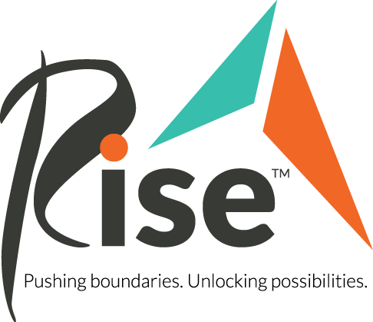
What changes were made as a result of the 2019 Legislative Session?
After a 7% cut to disability services in 2018, last legislative session focused on regaining funding to help increase the wages of the Direct Support Staff (DSPs), who are crucial to helping people with disabilities thrive. In 2019, the legislature approved for the Disability Waiver Rate System (DWRS) to be updated every two years as a result of automatic inflationary adjustment, rather than every five years. However, the Competitive Workforce Factor (CWF) included in the DWRS passed at 4.7%, which means funding remains lower than the funding amount prior to the 2018 cut.
What is the Disability Waiver Rate System?
According to the Minnesota Department of Human Services, “The Disability Waiver Rate System (DWRS) is a centralized system that calculates rates for home and community-based services provided under the disability waivers. The system is based on research completed on the average costs to deliver home and community-based services in Minnesota.”
Why is funding for direct support professionals (DSP’s) important?
Direct Support Professionals provide critical support to persons with disabilities, so that they can thrive as independently as possible. Wages for DSP’s are set through the Disability Waiver Rate System, and the wages continue to be less than competing professions, with the current hourly rate averaging at $13.15. This hourly pay is 17% less than jobs requiring the same skills, which has led to a crisis in recruitment for DSP’s, and DSP’s are vital to the lives of the 32,000 people with disabilities in Minnesota. Additionally, current DSP retention rates are 43.9%, thus making high turnover rates a serious problem that creates a workforce crisis. We need workers who want to stay in the position.
What is Rise’s 2020 Legislative Goals?
Each year, Rise supports the legislative goals of the Minnesota Best Life Alliance, a nonpartisan coalition of Minnesota service providers, caregivers, self-advocates, family members, and community partners advocating for Home & Community-Based Services that support people with disabilities and older adults. The 2020 legislative proposals present options for legislators to continue making direct support positions more attractive to current and prospective caregivers, in order to fix the workforce crisis surrounding disability services high turnover rates and low retention rates.
What is being debated about the Disability Waiver Rate System this legislative session?
Continuing to refine the DWRS so it’s an accurate reflection of market costs, as well as making recommendations on how the DWRS can be responsive to the impacts of local and statewide minimum wage increases, all aim to address the high turnover rates and staffing shortages that affect disability support services around the state. These are two of the issues Rise is advocating for this legislative session regarding the DWRS, however these are some of the first steps, as many refinements are needed to DWRS, in order to truly create a positive change in the disability services profession.

Why does the Competitive Workforce Factor (CWF) remain an issue in 2020?
Implementing regular adjustments to the CWF would continue to reduce the wage gap that exists between disability services jobs with those of competing occupations.
What would a tax credit do for Direct Support Professionals?
Because of the wage disparity between disability services wages with wages of competing occupations, a tax credit would aim to address the wage disparity, and ultimately increase the number of workers and retention rates in this profession.
What can you do to get involved?
High retention rates and low wages have created a crisis in disability services recruitment that can be fixed with your advocacy! DSP’s are needed for people with disabilities to live their best lives!
- Know your legislators and reach out to them by emailing, calling or writing letters to them! Learn more about how you can advocate for Rise’s legislative goals at rise.org/advocacy
- Be a part of Disability Day at the Capital on March 10, 2020.
- Use the following link to sign up for our email list to receive regular legislative updates. http://bit.ly/31iQBJ9
Who to contact for any questions about Rise’s 2020 Legislative Priorities:
Lauren Klemstein, Government Affairs Intern
Phone: (763)783-2813
Email: lklemstein@rise.org

